MOTION CONTROL HARNESS

- PARTS:

QUANTITY: PART #: NOMENCLATURE: LENGTH:

2 PER MACHINE 211021-2 HOLDER, CABLE TRACK N/A

1 PER MACHINE 19072-1 CABLE, X MOTOR POWER 120 INCHES

1 PER MACHINE 19072-1 CABLE,Y MOTOR POWER 80 INCHES

1 PER MACHINE 19072-1 CABLE, Z MOTOR POWER 190 INCHES

1 PER MACHINE 19072-1 CABLE, THETA MOTOR POWER 190 INCHES

7 PER MACHINE 43086- SCREW, BD HD, 6-32 X 3/4” N/A

1 PER MACHINE 43013- SCREW, BD HD, 6-32 X 5/8” N/A

6 PER MACHINE 43236- SCREW, SOC HD BTN, 6-32 X ¼” N/A

4 PER MACHINE 41590- STANDOFF, 6-32 X ½” N/A

4 PER MACHINE 42500 NUT, HEX, 6-32 X ¼” N/A

4 PER MACHINE 43135- SCREW, BD HD, 6-32 X 3/16” N/A

2 PER MACHINE 212030-2 BLOCK, CABLE HOLDER, Y-AXIS N/A

1 PER MACHINE 18707-3 CABLE, LASER SIGNAL 200 INCHES

2 PER MACHINE 217039-LVX CABLE, Y-AXIS RIBBON 132 INCHES

1 PER MACHINE 217040-LVX CABLE, X-AXIS, RIBBON 63 INCHES

6 PER MACHINE 212031- COVER, CABLE CARRIER N/A

2 PER MACHINE 46863-1 BRACKET, MOUNTING N/A

2 PER MACHINE 46863-2 BRACKET, MOUNTING N/A

1 PER MACHINE 46862-1 CARRIER, X CABLE 55 LINKS

1 PER MACHINE 46862-2 CARRIER, Y CABLE 52 LINKS

1 PER MACHINE 46855- TUBING, FLEX, 6 COLOR 180 INCHES

1 PER MACHINE 217063-14 CABLE, CAMERA VIDEO SIGNAL 180 INCHES

- ASSEMBLY:

- REMOVE THE TRACK COVERS.

- LAY THE TRACK DOWN WITH THE OPEN SIDE UP.

- LAYOUT THE TRACK, CABLES, AND AIR TUBING, ACCORDING TO DIAGRAM 1.
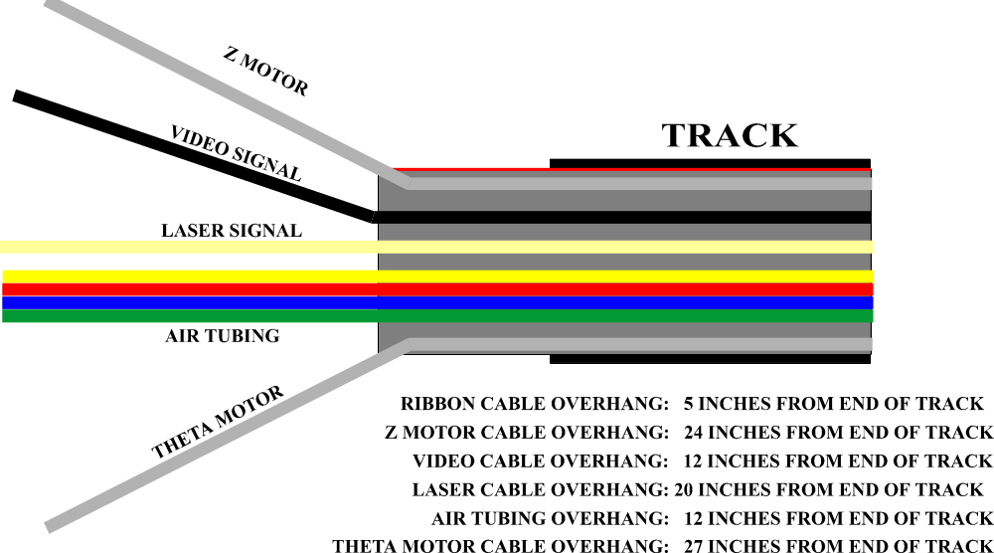

DIAGRAM 1

- HOLD THE CABLES AND AIR TUBES IN PLACE BY MOUNTING THEM TO THE BLOCK AND BLOCK COVER, ONCE THE CABLES AND AIR TUBES ARE SET TO THE CORRECT OVERHANG.

- ALTERNATELY TAPE THE Z MOTOR CABLE AND LASER CABLE TO THE VIDEO CABLE AT EQUALLY SPACED INTERVALS WITHIN THE TRACK.

- TAPE THE LASER CABLE TO THE AIR TUBING AT EQUALLY SPACED INTERVALS WITHIN THE TRACK

- TAPE THE AIR TUBING TO THE THETA MOTOR CABLE AT EQUALLY SPACED INTERVALS.

- MOUNT A BLOCK AND COVER ON THE CABLES AND AIR TUBES WITHIN 2 INCHES OF THE OPPOSITE END OF THE X TRACK.

NOTE 1
IT IS CRITICAL TO MAINTAIN THE SAME CABLE ARRANGEMENT FROM ONE END OF THE X-Y TRACKS TO THE OTHER. ANY VARIATION WILL CAUSE MOTION CONTROL PROBLEMS OR LAYOUT PROBLEMS.

- PLACE THE X MOTOR CABLE NEXT TO THE Z MOTOR CABLE,, ACCORDING TO DIAGRAM 2.

- TAPE THE X MOTOR CABLE, TO THE Z MOTOR CABLE, 8 INCHES FROM THE END OF THE
X TRACK.
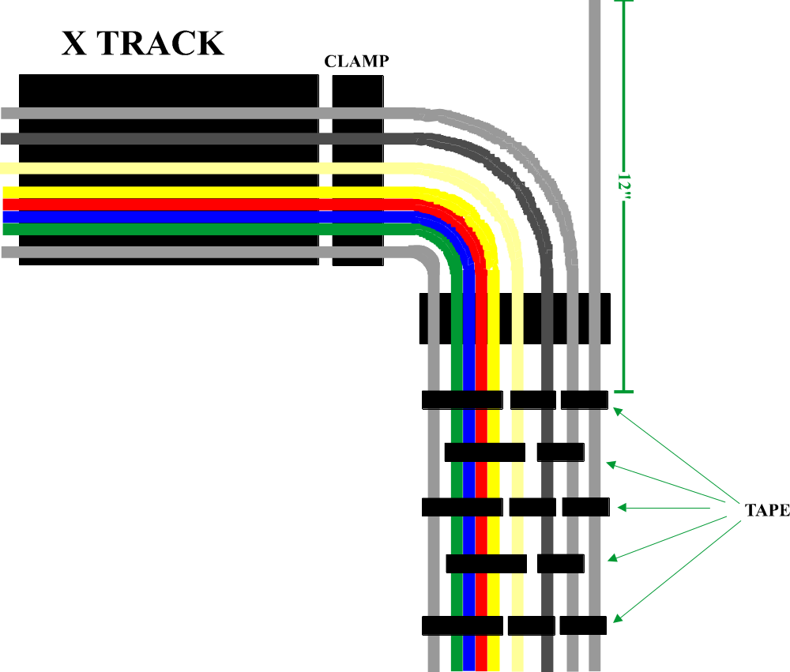

DIAGRAM 2

- PLACE A CLAMP OVER THE CABLES AND AIR TUBES, ACCORDING TO DIAGRAM 2.

- TAPE THE REMAINING CABLES AND AIR TUBES TOGETHER, ACCORDING TO DIAGRAM 2.

- THE TAPED AREA SHOULD BE ONLY 41 INCHES LONG. NO LONGER THAN THE Y TRACK LENGTH.

- PLACE THE TWO Y RIBBON CABLES OVER THE TAPED CABLES WITH 5 INCHES OF OVERHANG.

- SLIDE THE Y TRACK ONTO THE TAPED CABLES AND Y RIBBONS UP TO THE CLAMP.

- PLACE ANOTHER CLAMP ON THE CABLES AT THE BOTTOM END OF THE Y TRACK.

- TRACK INSTALLATION:

- ATTACH THE MOUNTING BRACKETS TO THE HEAD PLATE AND THE Y TRACK PLATES.

- INSTALL THE MOTION CONTROL HARNESS TO THE MOUNTING BRACKETS.

- ADJUST THE CABLE CLAMPS AND SECURE THEM TO THEIR RESPECTIVE MOUNTING POINTS.

- ROUTE THE CABLES AROUND THE STANDOFFS ANDMOUNT THE HEAD BOARD AND THE INTERCONNECT BOARD.

- FINISH THE X RIBBON CABLE, ACCORDING TO THE PROCEDURE FOR THAT ASSEMBLY.

- PLACE BLACK ELECTRICAL TAPE AROUND THE RIBBON CABLE WHERE IT COMES INTO CONTACT WITH THE HEAD AND INTERCONNECT BOARDS. THIS WILL AVOID DAMAGE DUE TO FRICTION AND CHAFING.

- FINISH THE TOP END OF THE Y RIBBON CABLE, ACCORDING TO THE PROCEDURE FOR THAT ASSEMBLY.

- PLACE BLACK ELECTRICAL TAPE AROUND THE RIBBON CABLE WHERE IT COMES INTO CONTACT WITH THE METAL PLATE NEAR THE TRAILING CABLES. THIS WILL AVOID DAMAGE DUE TO FRICTION AND CHAFING.

- SLIDE THE 36 INCH LONG ½” BLACK SLEEVING OVER THE TRAILING CABLES.

- ROUTE THE TRAILING CABLES AROUND THE POST AND THROUGH THE OPENING IN THE TABLE.

- FINISH THE MOTOR POWER HARNESS ACCORDING TO THE PROCEDURE FOR THAT ASSEMBLY.

- ROUTE THE AIR TUBING TO THE AIR REGULATORS.

NOTE 2
ENSURE PROPER SLACK AND SPRING IN THE TRACK ASSEMBLIES BY PUSHING THE HEAD PLATE IN ALL FOUR DIRECTIONS AND NOTING THE TENSION OF THE TRACKS. LIFT EACH TRACK AT THE BEND AND NOTE THE TENSION.

